**Code:**

**#Code1**

**import socket**

**def server_program():**

**# get the hostname**

**host = socket.gethostname()**

**port = 5000 # initiate port no above 1024**

**server_socket = socket.socket() # get instance**

**# look closely. The bind() function takes tuple as argument**

**server_socket.bind((host, port)) # bind host address and port together**

**# configure how many client the server can listen simultaneously**

**server_socket.listen(2)**

**conn, address = server_socket.accept() # accept new connection**

**print("Connection from: " + str(address))**

**while True:**

**# receive data stream. it won't accept data packet greater than 1024 bytes**

**data = conn.recv(1024).decode()**

**if not data:**

**# if data is not received break**

**break**

**print("from connected user: " + str(data))**

**data = input(' -> ')**

**conn.send(data.encode()) # send data to the client**

**conn.close() # close the connection**

**if __name__ == '__main__':**

**server_program()**

**#Code2**

**import socket**

**def client_program():**

**host = socket.gethostname() # as both code is running on same pc**

**port = 5000 # socket server port number**

**client_socket = socket.socket() # instantiate**

**client_socket.connect((host, port)) # connect to the server**

**message = input(" -> ") # take input**

**while message.lower().strip() != 'bye':**

**client_socket.send(message.encode()) # send message**

**data = client_socket.recv(1024).decode() # receive response**

**print('Received from server: ' + data) # show in terminal**

**message = input(" -> ") # again take input**

**client_socket.close() # close the connection**

**if __name__ == '__main__':**

**client_program()**

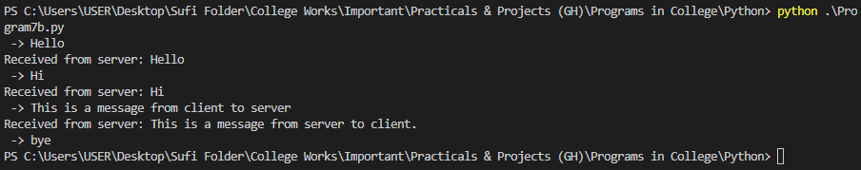**Outputs:**

